**2025 (FY 2026)**

**Minoh Citizen Exhibition**

**Application guidelines**

**68th**

**Minoh Citizen**

**Exhibition**

**~Enter Now~**

**Everyone age 15 and over! We are waiting for your entries!**

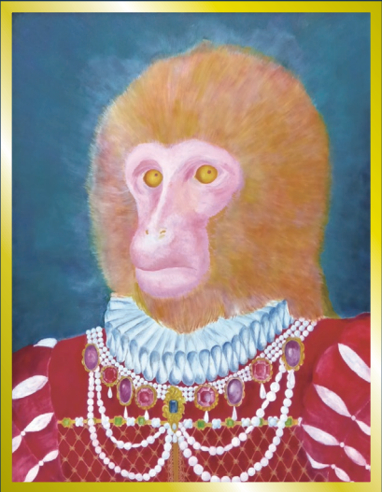

**《 Title calligraphy（箕面市民展）：アサンプション国際中学校高等学校 書道部 高 3 藏野心咲さん》**

**《 Title calligraphy（作品募集）：アサンプション国際中学校高等学校 書道部 高 3 大島歩乃佳さん》**

**《 Illustration: アサンプション国際中学校高等学校 美術部 高木郁乃莉さん（R7 年 3 月卒業） 》**

**Sponsorship Minoh City, Minoh City Board of Education, Minoh City Art Association**

**Management Minoh-City Foundation of Culture**

**68th Minoh Citizen Exhibition**

**1. Objective**

**2. Location**

**3. Exhibition date**

**4. Requirements**

**5. Categories・Regulations**

To have an exhibition that any Minoh citizen can participate in, to foster a society that cultivates individuality and lifelong learning.

Minoh Culture and Communication Center South Building (*minami kan*)

(5-10-23 Minoh, Minoh City) (previously Naka Kindergarten)

25 October (Saturday) - 2 November (Sunday) 2025

10:00 a.m. - 5:00 p.m. **(last entry 4:30 p.m.)**

※Will close at 3:00 p.m. on 2 November (Sunday) **(last entry 2:30 p.m.)**

Those age 15 and over who live, work or study in Minoh City  
(Excluding Junior High School students. Members of clubs/classes

and other similar organisations operating in Minoh City can apply.)

1 item per category can be entered per person ※Free to enter

Please submit your work framed in acrylic (panel mounting is also acceptable) or a similar material (glass is not permitted)

Hanging works must be equipped with metal fittings or strings/rods.

|  |  |  |
| --- | --- | --- |
| **Category** | **Type・Genre** | **Regulations for the works** |
| **Painting・**   **Carving** | Japanese painting・Western painting・Woodblock print・Mixed media・Carving・Contemporary art | ・Framed picture within size 50 ( 116.7 x 116.7 cm). Works that extend to the sides of the canvas, mixed media, etc. are also permitted  ・Carvings, etc. should be life size or smaller, able to be carried and exhibited  ・You must include an explanation of your work (written on postcard sized white card) and bring it when delivering the work |
| **Photography** | Photographs | ・The photo should be A4 size or larger, and must fit within a full sheet (45.7 cm x 56.0 cm).  ・The long side of the frame or panel should be 73 cm or less.  ・Composite photographs should be arranged so that they fit within the above frame and panel sizes (any size or number of photos are acceptable).  ・As of this year, the smartphone and tablet are merged here. . |
| **Craft** | Pottery・Wood carving・Dyeing・Cloisonne ware (Shippo)・Metal clay  ・Paper cutting (Senga)・Tsumami-e・Dolls・Noh masks・Porcelain・Embroidery, etc.  ※Please write in detail what your  object is on the application sheet. | ・3D objects, etc. should be life size or smaller, able to be carried and exhibited  ・Surface must be within 180 x 180 cm  ・Framed works within size 50  ※Small works will be displayed in cases or on pedestals  ・You must include an explanation of your work (written on postcard sized white card) and bring it when delivering the work |
| **Calligraphy** | Kanji・Kana・Chowa-tai・  Seal engraving (Tenkoku)・Character carving (Kokuji)・Penmanship | ・Framed works , hanging scroll (jikusou), book (sasshi)  - Vertical artwork: within 182 cm high x 90 cm wide  - Horizontal artwork: within 90 cm high x 182 cm wide  Scroll (makimono), folding book (jou)  - Vertical artwork: within 35 cm high x 400 cm wide  (Due to venue limitations, only part of the exhibition will be displayed)  ・The above dimensions refer to those of the complete work.  (except for the verticle dimensions of a hanging scroll)  ・You must write a script of the calligraphy text on a postcard-sized piece of paper and attach it |

**・The Citizen Exhibition requires pre-application (during the application period).**

**・Works will not be accepted without pre-application.**

**・Please make sure that your submitted fully complies with the regulations.**

**6. Application**

● Application period: 18 September (Thursday) - 1 October (Wednesday) 2025 (non-negotiable)

● How to apply (Japanese only): Reception Counter / Online Form / Post

① Reception counter application

○ Please bring the "application form" (attached) in person to these places.

Reception hours: 9:00 a.m. - 5:00 p.m.

・Minoh City Citizens Meeting Building (closed every 3rd Wednesday of the month)

・Minoh City Higashi Lifelong Learning Center (closed Monday) (excluding public holidays)

・Minoh City Seinan Lifelong Learning Center (closed Monday) (excluding public holidays)

② Online form application

○ Please apply using the online form on the Minoh-City Foundation of Culture Website.

※After completing the application, an email will be sent from minohart@minoh-bunka.com .

If you do not get an email within a few days, please contact the Citizens Meeting Building.

In addition, the reply is occasionally marked as spam or junkmail. Please be sure to check.

③ Post application

○ Please send the "application form" (attached) to the Citizens Meeting Building.

・Address:

Citizen Exhibition Manager (Shiminten-gakari), Citizens Meeting Building (Shimin Kaikan)

4-6-1 Nishishoji, Minoh City 〒562-0003

※Post date (date sent) must be by 1 October (Wednesday)

※After receiving the application, we will call your phone for confirmation. If you do not   
 get a phone call within a few days, please contact the Citizens Meeting Building.

**7. Delivering works**

**19 October (Sunday) 2025**

・Hours: 11:00 a.m. - 3:00 p.m. (non-negotiable)

・Location: Minoh Culture and Communication Center South Building (*minami kan*)  
 (previously Naka Kindergarten)

・Warning: Works must be delivered in-person on this date to be accepted.   
 (cannot be sent in advance via post, etc.)

- Please complete the required information on the "Safekeeping receipt" and   
 "Artwork tag" and bring it with you.

- The "Artwork tag" must be attached to the back of the artwork before delivery

- We do not accept packaging materials, etc.

・Artworks are restricted to those you have made yourself that have not been shown before. You cannot   
 submit the same work more than 1 time. If you do not follow these rules, your entry will be cancelled   
 (even after the results are announced).

**8. Warnings**

**9. Judges**

**10. Award ceremony**

**11. Collecting works**

**12. Notes**

**13. Inquiries**

・Artworks thought to violate nature conservation and public order and morals will not be accepted.

・Portrait rights and copyright of exhibited artworks is the responsibility of the artist.

・Fresh flowers and similar works cannot be accepted. Also, electricity cannot be used.

・Objections to the evaluation process, the location of the exhibition and our methods will not be accepted.

Minoh City Art Association Members

Date: 2 November (Sunday) 2025 from 1:00 p.m. (planned)

Location: Small Hall, Maple Hall, Minoh City

**3:15 - 5:00 p.m. 2 November (Sunday) 2025【non-negotiable】**

・Works can be collected from the exhibition location in exchange for a safekeeping receipt.

・There is nowhere to keep them after the exhibition period. You must collect works during the   
 designated time.

※Artworks that are not collected on the designated day will be disposed of.

・Care will be taken with the artworks but the organisers take no responsibility for damage or loss etc. due to 'acts of god' or natural disasters. Those submitting works should take out insurance if needed.

・Some works may have photos taken of them which will be used for PR or other similar purposes to promote the Minoh Citizen Exhibition. Attendees are also allowed to take photos of the works, etc.

・Current or former members of the Minoh City Art Association can exhibit works but they are not eligible to receive awards.

**Location Map**

Minoh-City Foundation of Culture

Minoh City Citizens Meeting Building

4-6-1 Nishishoji, Minoh City 〒562-0003

※Closed every 3rd Wednesday of the month

TEL: 072-723-2525

E-mail: minohart@minoh-bunka.com

※ If travelling by car, please use the parking lot   
 next to the building. (fee applies)

**《 Last year’s first prize winners 》**

These first prize winning works are currently displayed in the main building of Minoh City Hall

**Painting・Carving**

**Photography**

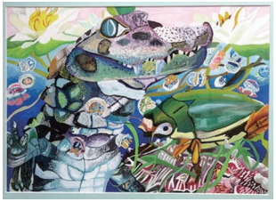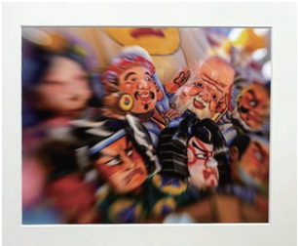

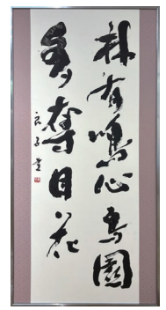

**Craft**

**Calligraphy**

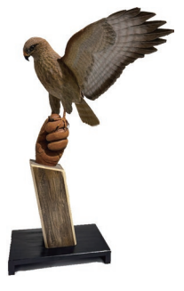

**《Winners of the first prize》**

Painting・ Carving

榧維真さん 「セベクの水浴び」

Photography

宮崎憲子さん 「福来たれ！」

Craft

鷹野隆義さん 「保護されたノスリの若い鳥」

Calligraphy

伊木良子さん 「林有鳴心鳥園多奪目花」

